1. Intro to Semantics: ARIA

HTML is built in with a lot of things, but no standardized dropdown menu, so we need to learn how to express semantics that HTML cannot express on its own.

1. Why ARIA

Accessible Rich Internet Applications

WAI-ARIA or ARIA

Adding role and aria-checked attributes cause the node in the accessibility tree to be modified. It does not changed appearance, behavior, does not add focus ability, does not add keyboard event handling.

1. Quiz: First Steps with ARIA
2. What can ARIA do for you?
3. Roleplaying

A role is a shorthand for a ui pattern. Roles belong on the same element as tabindex.

ARIA 1.0 roles: https://www.w3.org/TR/wai-aria-1.0/#roles

ARIA 1.1 roles (draft): https://www.w3.org/TR/wai-aria-1.1/#roles

ARIA 1.1 practices guide (draft): https://www.w3.org/TR/wai-aria-practices-1.1/

1. Quiz: Custom radio button group with ARIA

Set attribute for the radio group as role:radiogroup.

Set each button to role:radio.

Then use the changefocus function:

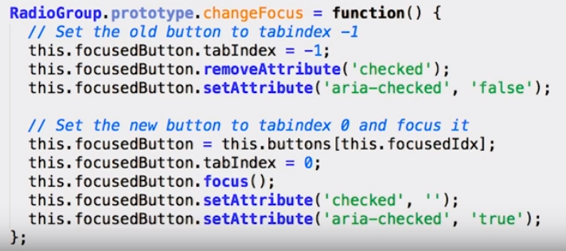

1. More Ways to Label

Aria-label like a hamburger menu can be useful. Aria-label overrides traditional element. Aria-label on any element.

1. Quiz: Name That Element!
2. Breather
3. Default Semantics and Landmarks
4. ARIA Relationships

Semantic relationship

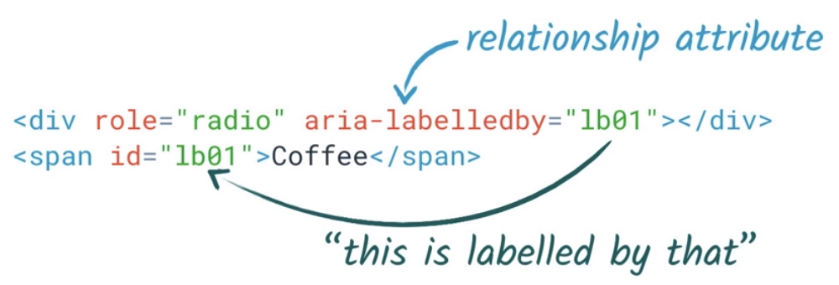

Aria-owns children comes after native children.

1. Quiz: Combo Box

To hear feedback in the combo box, lots of steps.

Aria-activedescendant, aria-posinset, and aria-setsize.

1. Hidden in Plain Sight

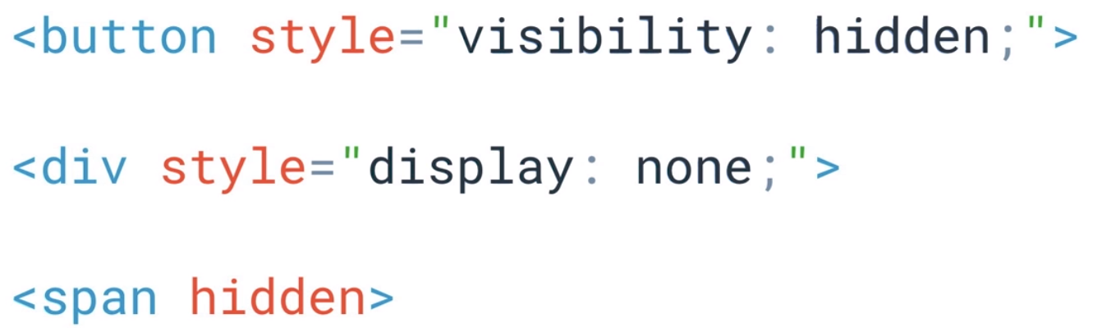

Also hides from assistive technology users. There are ways to let aria know an item is hidden from normal users.

1. Quiz: Name That Element Round 2
2. Recap so far
3. Introducing ARIA Live

Status messages can be read before targeted. Polite = tell the user after you do what you are doing. Assertive = interrupt the speech and tell them immediately.

1. Atomic Relevant Busy

Aria-atomic reads the whole container. Aria-relevant indicates what types of changes should be told to the user.

1. Recap

ARIA is exhausting. DOM + ARIA = an accessibility tree for all users.

1. Quiz: Modal Dialog Quiz
2. Outro Lesson 5

What a mess.